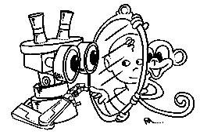 | MIRROR  IST–2000-28159  Mirror Neurons based Object Recognition

Deliverable Item 4.4

Preliminary results of the behavior development experiments

(Planning to reach for a rotating rod: Developmental Aspects)
Delivery Date: November 15, 2002
Classification: Public
Responsible Person: Prof. Claes von Hofsten – University of Uppsala
Partners Contributed:
Short Description:
The dynamic properties that have to be anticipated when reaching for an object are not just those related to object position, but also changes in the orientation and form of the object. In the present experiment infants’ pre-adjustments of reaching movements to a rotating object was studied. Few main questions were asked. First, will young infants adjust the orientation of the hand to a rotating rod when reaching for it? Secondly, are these adjustments geared to object velocity? Thirdly, will the adjustments anticipate object rotation? Finally, will the adjustments only affect the grasping phase of the reach like in adults or will the approach be affected as well? Kuypers (1973) andLawrence and Kuypers (1968a, b) showed that the neural pathways controlling the proximal and distal muscle groups have different organizations in the adult monkey. This differentiation becomes quite apparent with maturation. If the rotational adjustments of the hand are independent of the approach adjustments in adult subjects, then the emerging independence of these mechanisms will reflect the maturation of the manual motor system.
In several ways, the results indicate that approaching and grasping an object are independent actions.
 | Project funded by the European Community under the “Information Society Technologies” Programme (1998-2002)

Content list

1. Introduction 2
2. Method 2
3. Results 4
4. Discussion 8
5. References: 9

Introduction
All actions are directed into the future and require information about upcoming events. This is especially crucial when acting on a moving object. In such a situation not only ones own movements must be anticipated but also the motion of the external object. Earlier research has found that young infants are able to catch fast objects, and this is accomplished by reaching toward a future position where the hand and the object will meet (von Hofsten & Lindhagen, 1979; von Hofsten, 1980, 1983). Infants show this ability as soon as they reach for stationary object.
The dynamic properties that have to be anticipated when reaching for an object are not just those related to object position, but also changes in the orientation and form of the object. Jeannerod and associates (Stelmach, Castello & Jeannerod, 1993; Paulignan, Jeannerod, MacKenzie, & Marteniuk, 1991) found such perturbations affected the grasp movement but not the approach movement. On the other hand, when the position of the object was perturbed, both the approach aspect and the grasp aspect of the reach were affected.
In the present experiment infants’ pre-adjustments of reaching movements to a rotating object was studied. Few main questions were asked. First, will young infants adjust the orientation of the hand to a rotating rod when reaching for it? It has earlier been found that infants orient their hand to the orientation of a static rod when reaching for it (von Hofsten & Fazel-Zandy, 1984). This ability was found to be present in 20-week-old infants but the adjustments to the rotating rod was then rather crude. Over the next 3 months the adjustments improved and they were to an increasing degree integrated with the approach. Secondly, are these adjustments geared to object velocity? Thirdly, will the adjustments anticipate object rotation? Finally, will the adjustments only affect the grasping phase of the reach like in adults or will the approach be affected as well? Kuypers (1973) and Lawrence and Kuypers (1968a, b) showed that the neural pathways controlling the proximal and distal muscle groups have different organizations in the adult monkey. This differentiation becomes quite apparent with maturation. If the rotational adjustments of the hand are independent of the approach adjustments in adult subjects, then the emerging independence of these mechanisms will reflect the maturation of the manual motor system.
The reaching movements were analyzed in terms of functional units each consisting of one acceleration and one deceleration phase. The rationale is that each unit represents a certain presetting of the movement. In order to redirect it, new energy has to be invested and that creates a new unit. Von Hofsten (1980, 1983, 1991) used this rationale for analyzing predictive patterns of reaching movements. In this study it was also used to analyze the rotational movements of the hand in preparation for grasping the object.

Method
Subjects: Two groups of infants participated in the study. The mean age in Group 1 was 26 weeks (+ 1 week). It consisted of 6 boys and 3 girls. The mean age in Group 2 was 44 weeks (+ 1 week). It consisted of 3 boys and 7 girls. All infants were full terms. In addition to these infants, a group of 10 adults participated. They were all healthy.
Apparatus (see Figure 1): The stimulus was a rod, 20 cm long and 1 cm in diameter. At its center it was perpendicularly attached to the axis of a motor with adjustable speed. The motor was positioned in front of the subject behind a black curtain. Thus the rod rotated around its center in the fronto-parallel plane. The coupling to the motor was a rigid magnetic one and if enough force was applied to the rod it could be ripped off its attachment. Only the rod itself and a small section of the axis of the motor were visible to the subject. The motion of the rod and the movements of the subject’s hands were registered with a Proreflex system (Qualisys). Small passive markers were attached to the wrist and the base of the thumb and the little finger. Two additional LEDs were attached to the end-points of the rod. Five Proreflex cameras were directed so that at least two of them would register the markers at each point in time. Sampling was made at 240 Hz. A video camera monitored the subject during the experiment. A pre-trigger system was used to start recording the reaching events. The experimenter started it at the moment of grasping. The pre-trigger was set to sample measurements from 3 s before until 4 s after it was pressed.

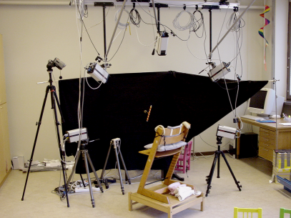 | 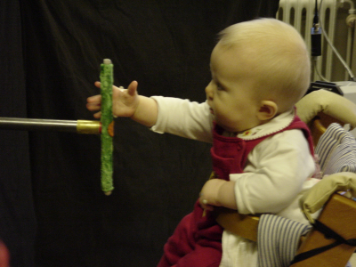
Figure 1: Left: Experimental Set-up used during the experiment; Right: Infant performing grasping

Procedure: At the start of the experiment, the infants were placed in an infant chair in front of the rod at a distance that was out of reach. The experimenter who controlled the position of the infant chair entertained the infant between trials. At the different trials, the rod was either stationary or rotated in the frontal plane. When it was stationary, its orientation was either horizontal or vertical. Two velocities were used: 18°/s and 36°/s. The direction of motion was either clockwise or anti-clockwise. Thus, there were 6 conditions in the experiment. Each of them was presented twice making altogether 12 trials. The order between trials was randomized.
When the rod was set to the appropriate condition and the equipment was ready to measure the movements of the child and the rod the chair with the subject was quickly moved within reaching distance. If the infant was distracted at the beginning of a trial, the experimenter tried to make the infant attend to the rod by pointing to it. If the infant became unhappy during the experiment, it was immediately interrupted, the chair turned around, and the parent(s) recruited to soothe it. When the infant became happy again, the experiment was continued. This scenario was actually rather uncommon. Most infants eagerly reached for the rod at all trials. For some infants the experimenter actually had to hold the arms of the infant when the chair was moved forward to reaching distance of the rod, otherwise they would reach forward far too early, and have their arms already stretched out when the chair was moved forward.
Data analysis: For each individual reach, the result of the analyses was compared to the video recording of the same action by two experimenters. If too few markers were visible during the reach, or the subject was judged to engage in something else than reaching for the object along its longitudinal axis, the reach was excluded. From the video certain qualitative judgments were made. The grasp was either scored as overhand, underhand, or vertical. 280 reaches were analyzed.
All data were collected on line and saved within the Qualisys software. They were later transferred to calculation programs (Matlab) for analysis. The first step of the analysis was to filter the data with a 16Hz low pass median filter. The hand movements were analyzed in terms of translation in 3-D space and rotation in the fronto-parallel plane (the plane of rotation of the rod). The translational and rotational movements of each individual reach were divided up into functional units, each consisting of one acceleration and one deceleration phase. The velocity increase threshold for new units was set to 20 mm/s for the translational units and 15°/s for the rotational units.
Secondly, he angular difference at encounter between the hand and the rod was analyzed. Finally, a correlation analysis was performed between the approach velocity and the rotational velocity at each point in time for individual reaches was performed.

Results
Almost all grasped the rod from above: 86% of the 6-month-olds, 96% of the 10-month-olds, and 92%of the adults.
A. Analysis of movement units.
Figure 2 shows two examples of the structuring of reaches in terms of movement units. The example to the left shows rotational units and the one to the right shows translational units. Note that the rotational units are more distinctly separated in time than the translational units. The black horizontal line in each Figure shows the extent of the reach. There are 3 rotational units in Figure 2a and 4 translational units in Figure 2b.

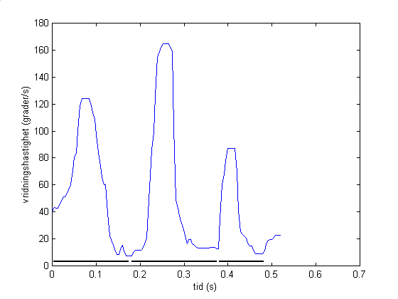 | 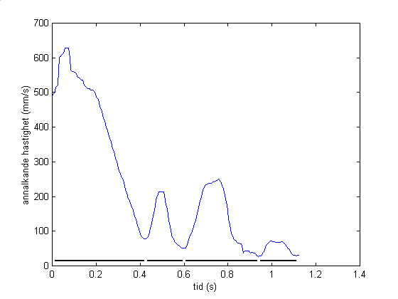
2a. Rotational units.  Vertical axis: Rotation velocity (°/s)  Horizontal axis: Time (s) | 2b. Translation units.  Vertical axis: translation velocity (mm/s)  Horizontal axis: Time (s)

There were more rotation units than approach units (F (1,26)=13.6, p<0.01). There was also an effect of age both for the number of approach units (F(2,26)=11.82, p<0.001) and the number of rotational units (F(2,26) = 8.41, p<0.01). There as no effect of rod rotation for either approach or rotation. These effects are illustrated in Figure 3 and 4.
Figure 3. The number of approach units as a function of rotational velocity of the rod and age.

Figure 4. The number of rotation units as a function of rotational velocity of the rod and age.
It has earlier been found that the position of the largest unit reflects the maturity of the reaching system (von Hofsten, 1991). Ideally the largest unit, the approach unit, should be the first one and the subsequent ones should have the function of preparing for the final grasping action. An effect of age on position of the largest unit was found for both the approach analysis (F(8.40, p<0.001) and the rotation-of-the-hand analysis (F(7.60, p<0.01). The largest approach unit was generally positioned more to the beginning of the reach than the largest rotation-of-the-hand unit (F(1,26)=8.32, p<0.01). The average position of the largest approach unit was 1.54, 1.33, and 1.06 for the 6-month-olds, the 10-month-olds, and the adults respectively. The corresponding values for the rotation-of-the-hand were 1.72, 1.40, and 1.28.
The average approach unit size increased with age (F(2,26)=6.462, p<0.01) but was not affected by the rotational velocity of the rod (F< 1.0). The average size of the rotation units was not affected by age (F(2,26)=2.06, p>0.1), but by the rotation velocity of the rod (F(2,52)=3.298, p<0.05). These effects are illustrated in Figure 5 and 6.
Figure 5. Average size of approach units.
Figure 6. Average size of rotational units.
The maximum approach velocity was clearly affected by age (F(2,26)=32.40, p<0.001) but not by the rotation velocity of the rod (F<1.0). The opposite was valid for the maximum rotation velocity of the hand. The rotation velocity of the rod clearly affected the maximum Rotational velocity of the hand. The trend was linear (F(1,26)= 8.26, p<0.01). However, there was no effect of age (F(2,26)=1.997, p>0.1). This is shown in Figure 7 and 8.
Figure 7. Maximum approach velocity.
Figure 8. Maximum rotational velocity of the hand.

B. Analysis of difference in angular position between the hand and the rod at the encounter.
This analysis showed that the angular difference decreased with age (F(2,26)=8.785, p<0.001). This is illustrated in Figure 9. The average difference was 30°, 24°, and 15° for the 6-month-olds, the 10-month-olds, and the adults, respectively. There was no effect of the rotational velocity of the rod, however (F=1.19).
Figure 9. Angular difference between hand and rod at encounter.

C. Correlation analysis
Correlating the approach velocity with the rotational velocity shows that they are only moderately related. On the average this correlation was found to be 0.28.

Discussion
In several ways, the results indicate that approaching and the grasping an object are independent actions. First, the analysis of movement units showed that the rotation of the rod affected the rotational adjustments of the hand but not the approach of the rod. The maximum approach velocity was not dependent on the rotational velocity of the rod but the maximum rotational velocity of the hand was. Finally, the small correlations between the rotational velocity and approach velocity support the conclusion that these two actions are relatively independent. These results support the earlier results by Jeannerod and associates (Stelmach, Castello & Jeannerod, 1993; Paulignan, Jeannerod, MacKenzie, & Marteniuk, 1991).
The rotation of the rod was found to affect the grasping action but not the approach action. When the rod rotated faster, the hand rotated faster as well. In other words, the subjects’ attempts to grasp the object appropriately took the rotation of the object into account. The results also indicate that the grasping of the object is geared to its rotation in such a way that the hand moves with the object.
The results show that the grasping of the rod is prospectively controlled. Irrespectively, of the rotational speed of the rod. The average angular difference between the hand and the rod was found to be the same irrespectively of the rotational velocity of the rod. In fact, the angular difference was the same when the rod was stationary as when it moved with 36°/s. A major effect of age was found, however. The average angular difference decreased with age from 30° at 6 months of age to 15° in adults.
Age effects in manipulatory skills between 6-month-olds and adults is expected. It is more remarkable when they do not show up. Two of the measures of the rotational movements of the hand did not show any age effects. They were the size of movement units and the maximum velocity of the reach.

References:
Kuypers, H.G.J.M. (1973) The anatomical organization of the descending pathways and their contribution to motor control especially in primates. In J. E. Desmedt (Ed.) New developments in electromyography and clinical electrophysiology: Vol. 3. New York: Karger. (pp.38-68).
Lawrence, D.G. & Kuypers, H.G.J.M. (1968a) The functional organization of the motor system in the monkey: I. The effects of pyramidal lesions. Brain, 91, 1-14.
Lawrence, D.G. & Kuypers, H.G.J.M. (1968b) The functional organization of the motor system in the monkey: II. The effects of descending brainstem pathways. Brain, 91, 15-36.
Paulignan,Y., Jeannerod, M., MacKenzie,C.L., & Martenuik, R.G. (1991) Selective perturbation of visual input during prehension movements. 2. The effects of changing object size. Experimental Brain Research, 87, 407-420.
Stelmach, G.E., Castiello, U., & Jeannerod, M. (1994) Orienting the finger opposition space during prehension movements. Journal of Motor Behavior, 26, 178-186.
von Hofsten, C..(1979). Development of visually guided reaching: the approach phase. Journal of Human Movement Studies, 5, 160-178
von Hofsten, C. (1980) Predictive reaching for moving objects by human infants. Journal of Experimental Child Psychology, 30, 369-382.
von Hofsten, C.. (1983). Catching skills in infancy. Journal of Experimental Psychology: Human Perception and Performance, 9, 75-85.
von Hofsten,C. (1991) Structuring of early reaching movements: A longitudinal study. Journal of Motor Behavior, 23, 280-292.
von Hofsten, C. and Fazel-Zandy, S.(1984). Development of visually guided hand orientation in reaching. Journal of Experimental Child Psychology, 38, 208-219.
von Hofsten, C., and Lindhagen, K.(1979) Observations on the development of reaching for moving objects. Journal of Experimental Child Psychology, 28, 158-173.

