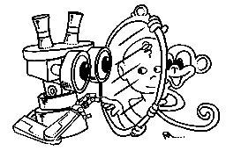 | MIRROR  IST–2000-28159  Mirror Neurons based Object Recognition

Deliverable Item 4.3

Preliminary Results of Monkey Experiments

Delivery Date: November 15, 2002
Classification: Internal
Responsible Person: Prof. Luciano Fadiga – University of Ferrara
Partners Contributed:

Short Description: This deliverable item describes the experimental procedures carried out during the first year of the project and some preliminary experimental data achieved in behaving monkeys and in humans (in the framework of the modification of the original program already anticipated in Deliverable 4.1.
In particular the deliverable describes: 1) A new method developed by our group to precisely design the 3D shape of the chamber to be fixed to the skull and the surgical procedure followed by us to implant the chamber in the macaque monkey. 2) The details of single unit recording procedure during the experimental sessions and the task the monkey has been conditioned to deal with. In brief, clinically characterized, isolated F5 neurons are recorded during monkey grasping. The response elicited by the same grasping action is recorded in different conditions of “visual feedback” on hand/object interactions, and for different classes of F5 neurons. Video recording of the grasping movements kinematic are performed simultaneously to compute hand grip and trajectory using a method that renders unnecessary the application of passive or active infrared markers on fingertips. 3) Some experiments performed in humans with transcranial magnetic stimulation aiming to investigate a possible role of a mirror-like system in speech perception.
Obviously, the achieved results and technical improvements will be available to the scientific community and this might be particularly relevant for the system we developed for kinematic recordings that, being markers free, could have also clinical applications, particularly in children studies.
 | Project funded by the European Community under the “Information Society Technologies” Programme (1998-2002)

INDEX

1. Introduction
2. Localization of the region on the monkey skull under which premotor area F5 is located
3. Modeling the chamber for neuron recordings
4. Surgical procedure
5. Neuron recordings
6. Experimental device and paradigm
7. Kinematic recordings
8. TMS studies in Humans
9. References

Introduction

This Deliverable describes in detail the monkey experiment we are currently performing aiming to investigate the role of visual feedback relative to hand self-observation during grasping execution. In the last part of this document (8), some additional data (with respect to the original plan) aiming to demonstrate that an acoustically triggered mirror-like system is present in humans, are shown.
The final goal of monkey experiments is to test if the visuomotor coupling at the basis of the “mirror” mechanism would be initially generated by the observation of one’s own acting effector, seen from different perspectives, performing repetitively the same action. It is possible that these different visual information are associated by the brain as “common signals” having in common the same motor goal. The system could become therefore capable to extract motor invariants also during observation of actions made by others.
To this purpose, we are recording the activity of single grasping neurons located in monkey F5 premotor area while the animal is executing a grasping movement in condition of manipulated visual information (e.g.: complete dark, brief flash of light during different phases of the movement). First of all, single neurons are characterization according to their preferred type of grasping. Successively, neurons are recorded during meaningful (for the neuron) grasping actions in different conditions of “visual feedback”. The activity is then analyzed by comparing the frequency of discharge in the different situations. Video recording of the grasping movements are performed simultaneously to compute hand grip and trajectory kinematic data.
Considering that the experiments has to be performed with behaving monkeys, we decided to optimize well established recording procedures by developing new methods to precisely characterize the region on the monkey skull under which premotor area F5 is located, to model the chronic implant that allows head fixation and the access to the cortex to be recorded, and to record kinematics parameters of the monkey grasping without using passive or active infrared markers on fingertips. This in order to ensure the comfort of the animal as well as the accuracy of microelectrode stereotaxic positioning.

- Localization of the region on the monkey skull under which premotor area F5 is located

A very important problem to solve before the surgical implantation of the chronic implant that allows the access to the cortex to be recorded (F5 premotor area), is to individuate the position on the monkey skull in correspondence of the region of interest. Given the enormous difficulties, for bureaucratic reasons, to obtain a magnetic resonance image of the monkey brain, we decided to use a new method of localization. We submitted the monkey to a computerized tomography (CT) scan and we acquired a series of horizontal slices (thickness, 1 mm) (Fig. 1).

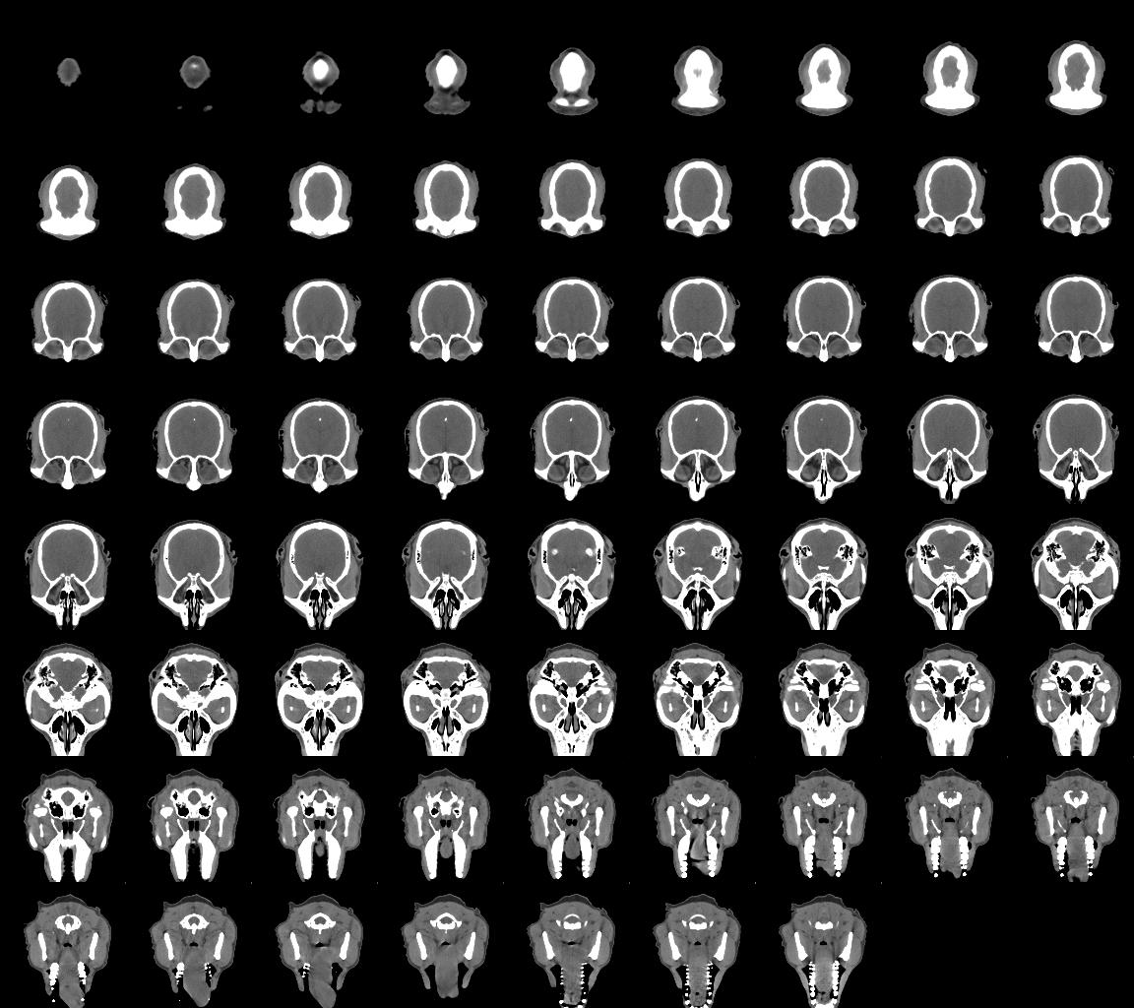 | Figure 1. Complete series of CT slices acquired from monkey MK1. The slice thickness is 1 mm. The slice pixel resolution is 0.24 mm. Note the high contrast between bone and soft tissues.

We reconstructed the 3D external surface of the skull by using the ETDIPS software, after converting the data into the Analyze format, and the system of coordinates was adjusted according to the standard stereotaxic system (orbitomeatal plane) (Fig. 2).

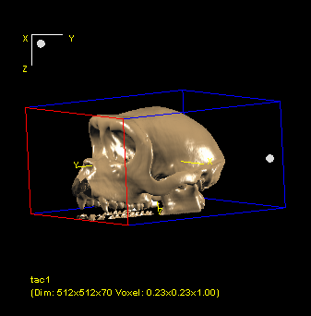 | 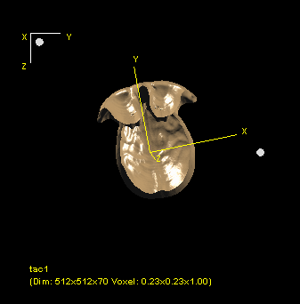
Figure 2. Anterolateral view of the 3D reconstructed skull of monkey MK1 | Figure 3. Internal surface of the reconstructed skull.

With a specifically designed software (created in our laboratory) we determined the position of the target cortex (frontal area F5) by using as references both the sulcal pattern impressed on the internal surface of the skull (Fig. 3) and the stereotaxic atlas by Szabo and Cowan (1984).

- Modeling the chamber for neuron recordings

We selected a cylindrical shape for the chamber because it is more easy to keep it safely closed with an O-Ring gasket on the plastic cover (see figure 8). The inferior surface of the cylinder was then modeled to perfectly replicate the skull curvature. This has important consequences because it reduces the possibility of leakage from the chamber and, at the same time renders unnecessary the use of acrylic cement, reduces the probability of infections and increases the duration of the implant.
Fig. 4

In order to obtain the perfect adhesion between the chamber and the bone, we modeled the chamber starting from a virtual 3D shape created with a commercial 3D designing software, on the basis of the real curvature of the bone. The obtained 3D file (see Fig. 5) was then sent to a path generating program (Mill Wizard, Delcam, UK) that outputs the correct G-code for driving a computer driven 3D milling plotter (Fig. 6).

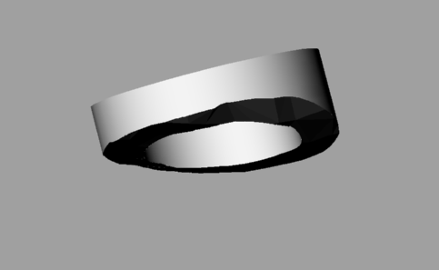
Fig. 5.

Fig. 6

We decided to build the chamber and all the other implant components (screws, head fixation spheres, etc.) in titanium because of its excellent bio-compatibility. Moreover, to stimulate a correct adhesion of the bone to the titanium, we coated it with hydroxyapatite (Ca10(PO4)6-(OH)2, HA). We followed a very new low temperature sol/gel coating procedure (Liu et al., 2001) to synthesize HA and to coat the metal. After drying at 80 °C, the coated titanium is calcinated at 450 °C in order to obtain crystalline HA and to induce its adhesion to the substrate. The chemical similarity between hydroxyapatite and mineralized bone increases the affinity of coated implants to host hard tissues. It is known that the growing of bone’s cells is stimulated by the coating and that the hydroxyapatite could form a substrate for optimal osteointegration and that this guarantees a high stability, because of the hard linkage between the bone and the implant.

The electron microscopy of one of our templates (figure 7) shows a total covering of the titanium by the hydroxyapatite matrix.

Fig. 7

- Surgical procedure

The most critical aspect during surgery is the respect of the thermal equilibrium of the exposed bone in order to maintain its vitality and allow its successive growth on the HA-titanium substrate. To this purpose, during the whole surgery and skull drilling in particular, care was taken in order to prevent bone overheating. With this goal in mind we modified the illumination source of an operative microscope from the traditional bulb lamp to a fiber optic cold source system and, during drilling, we continuously irrigated the operative field with saline. We designed a new system for head fixation during neuron recordings and new titanium screws that will improve implant duration. However, apart from these technical modifications, the surgical procedure was developed according to standard protocols. An example of it can be found in Umilta et al. (2001).
In order to implant the chamber and the head fixation system, the monkey was submitted to three surgical sessions. During each session the monkey head was fixated in a stereotaxic apparatus that allows to measure in stereotaxic coordinates (the orbitomeatal plane) the appropriate location of the different implant components.
During the first session four spheres were implanted by means of specially designed screws in order to allow the fixation of the head to the device mounted on the primate chair, which consists of four fixating rods with internal conic holes that are pulled onto the four titanium spheres (Fig. 8).

Fig. 8. Note the absence of infections or skin reactions to the implant.

During the second session the chamber was placed in the correct location on the skull and fixated by screws to the bone. After a phase of recovery, during the third surgical session, the bone inside the chamber was removed. The chamber was then covered by a plastic cap internally holding an o-ring gasket, that can be placed and removed simply by means of three screws.

- Neuron recordings

During experimental sessions, the behaving monkey seats on a restraining chair with the head fixated. Arms and legs are allowed to freely move.
A specially designed prototype of micromanipulator is firstly used to calibrate the electrode tip position by using as a reference point the center of an aluminium cap, indicated by a small tip, placed over the chamber. Then the electrode is moved to the desired location according to the stereotaxic coordinates of the target region.
The electrode penetrates with an angle of 40° (with respect to the sagittal plane) in the premotor cortex by means of an hydraulic advancer (Trent Wells, CA, USA; step resolution, 10 um).
Recorded spikes are amplified, filtered (World Precision Instruments, USA) and fed to an A/D converter for storage on a computer. The acquisition program has been specifically realized by our team. The electrical activity is acoustically amplified by an Audio Monitor (Grass Instruments, USA) to give to the experimenter a fundamental feedback during neuronal testing.
In order to be sure that the position of the chamber with respect to the recording system does not change, its inclination is frequently checked by using a specially designed device holding a metallic disk which reproduces exactly the inclination of the chamber as assessed immediately after the surgery. Shifts of the chamber can be detected by the presence of a not perfect contact between the chamber and the disk.
As soon as the neuron recordings set-up was established, the exposed cortex was elecrophysiologically mapped. This testing was absolutely necessary since the localization of the region of interest has been individuated by means of indirect cues, that is the pattern impressed by the cortex sulci on the inner surface of the skull, after 3D reconstruction of the CT scan. The only way to be sure to have really individuated the target area is to record the activity of the neurons during clinical testing. That is to say that the awake monkey is seated on the chair while the experimenter, in front of it, tests visual, motor and somatosensory stimuli in order to evoke a response from the recorded neuron. This is usually done by presenting different visual stimuli, by inducing monkey’s active movements (e.g. presenting to it some pieces of food), by passively stimulating monkey’s skin and so on. In addition, we microstimulated the recorded regions in order to establish the motor threshold and the somatotopy of the recorded region.
The clinical testing of the cortex delimitated by our chamber revealed that we successfully localized area F5, that is the target region of our experiment. In fact, we have found that both functional characteristics and intracortical microstimulation parameters found more rostrally are compatible with those of FEF area while more caudally are compatible with those of F4 area. Moreover, a preliminary testing of the area in between clearly indicates it as area F5 (see figure 9).

Fig. 9. Mesial and lateral views of the monkey brain showing the parcellation of the motor, posterior parietal and cingulate cortices. The areas located within the intraparietal sulcus are shown in an unfolded view of the sulcus in the right part of the figure.

- Experimental device and paradigm

To standardize the grasping movement, a specially designed apparatus has been prepared in our lab. It consists of a box located in front of the monkey, inside which little pieces of food are hidden (Fig.10).
Fig.10

In order to reach the food, the box could be opened by the monkey by means of a precision grip performed on a small plastic cube working as handle to open the door. An additional, outer door, sliding laterally, covers the to be grasped handle before the beginning of each trial (Fig.11).

Fig. 11

The monkey knows that it is allowed to start the grasping action at the aperture of the outer door. In this way the translucent handle becomes visible and the animal grasps it to open the inner door and to grasp the food. The handle is dimly back-illuminated by a red LED, allowing the monkey to correctly perform the grasp also in complete darkness.
Two triggering stimuli are generated by the apparatus and sent to a computer for spikes alignment. The first one signals the moment at which the monkey touches the handle. The second one is generated by a pyroelectric infrared sensor (adjustable in position), that can be used to signal precise spatial locations of the moving hand before the contact with the handle.

In order to test the experimental hypothesis (motor invariants firstly validate the visual information related to one own acting hand, then the system becomes capable to extract motor invariants also during observation of actions made by others), F5 premotor neuron activity is investigated in different experimental conditions:
- grasping in full vision
- grasping in dark with no hand visual feedback
- grasping in dark with instantaneous visual feedback before contact
- grasping in dark with instantaneous visual feedback at object contact

In conditions c and d, a very brief (few microseconds) xenon flash is triggered by the computer that controls task temporal sequences.

- Kinematic recordings

During grasping, hand/wrist kinematic is recorded by means of a 3D video acquisition system developed in our laboratory. The system uses a catadioptric camera to capture at high frequency (30 Hz) stereo images of monkey’s hand movements (Fig. 12). Note that the images are visible to the camera but not to the monkey, because of the presence of an infrared illuminator.

Fig. 12

Specifically designed 3D reconstruction algorithms are used to reconstruct frame by frame the 3D position of critical points (fingertips, wrist) extracted from stereo-images. This recording system gives us the advantage to measure kinematics parameters without placing markers on monkey’s hand.

Stereo vision uses different views of the same scene to build the tridimensional structure of it. Our two eyes see slightly different images of the world and the brain uses this difference to calculate relative distances. This gives us the depth sensation.
To obtain a tridimensional reconstruction of monkey’s grasping we decided to mimic the human visual system, and to capture two different views of the same scene. In order to avoid the problem of the synchronization, that is necessary when two videocameras are used to have different images of the same thing in the same moment, we utilized a catadioptric system. A catadioptric system is an optical system consisting of a combination of refracting (lens) and reflecting (mirrors) elements. By using mirror reflections of a scene, stereo images can be captured with a single camera (catadioptric stereo) (Fig.13).

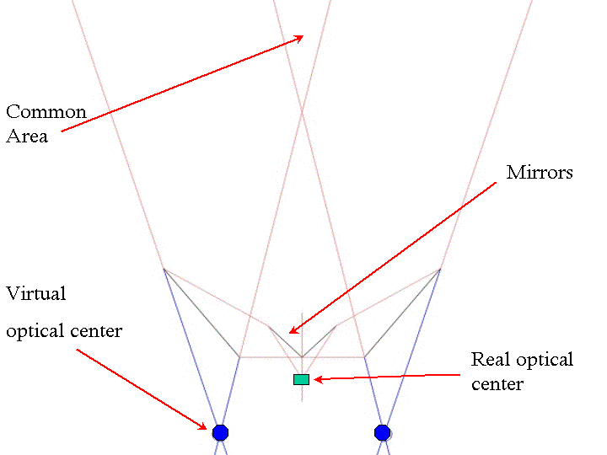

Fig. 13

The exact dimensions of the mirrors are calculated with trigonometric expressions starting from vertical and horizontal dimensions of the camera sensor. At the acquisition frequency of 30 Hz we acquire 640 x 480 pixels images and each of them is in turn subdivided into two 320 x 480 pictures representing the left and right views of the two virtual cameras (see Fig.13).
Since a catadioptric stereo system uses a single camera, there are several advantages:
- synchronization of two cameras is not necessary
- capture parameters of the two images are the same (e.g.: lens, sensor, blurring, lens distortions, focal length, spectral response, gain, offset, pixel size) and, for this reason, the system is easy to calibrate.
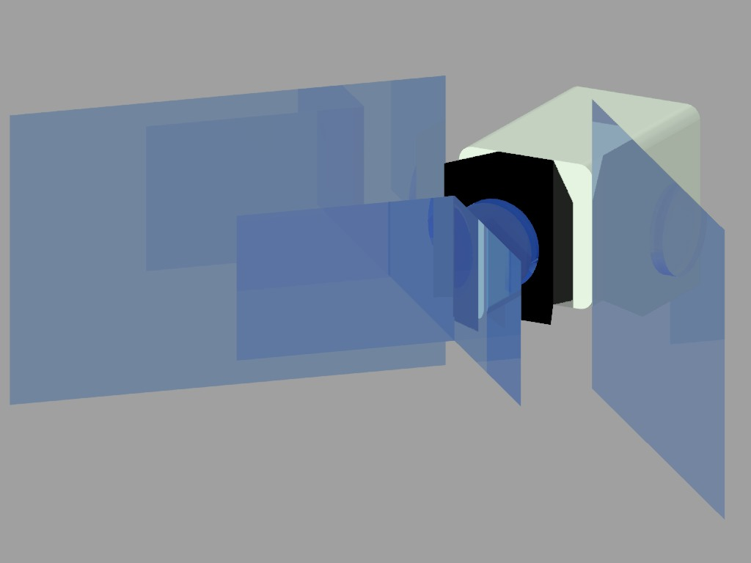
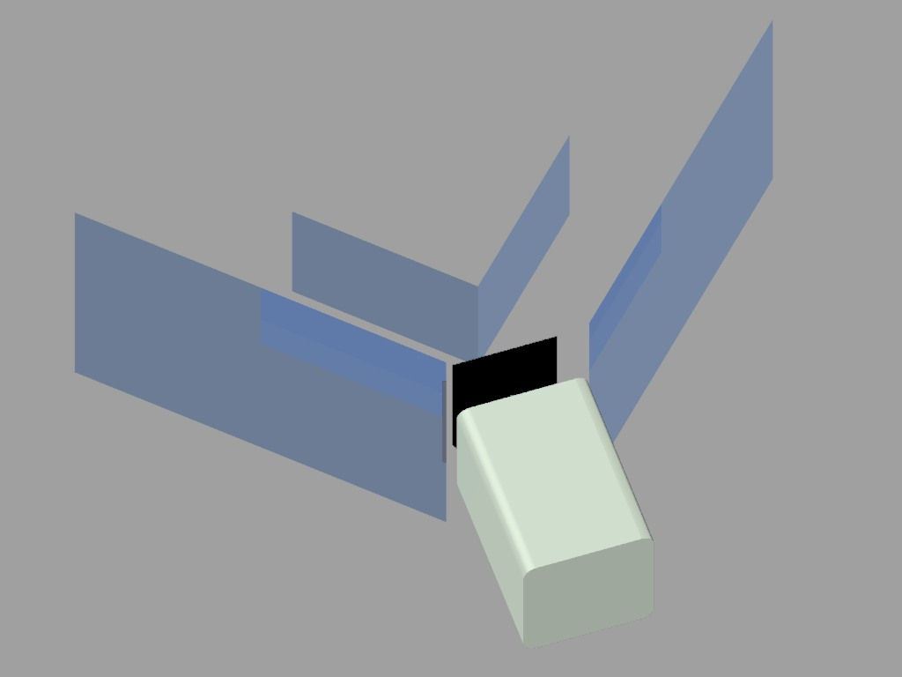

Fig. 14
The first step in order to use a stereo acquisition system is to calibrate the system. This procedure allows to individuate a correspondence between the points of the two bidimensional images and the 3D space seen by the two cameras.
We use a photogrammetric calibration, working on an object whose 3D geometry is perfectly known: a 252 x 196 mm chessboard (Fig. 15).

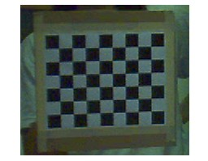

Fig. 15

While slightly moving the chessboard in different positions, different images of it are acquired for the calibration process. For each virtual camera, each image is analysed so that corners’ projections of the chessboard in the image plane are compared to the real chessboard 3D positions (Fig. 16).
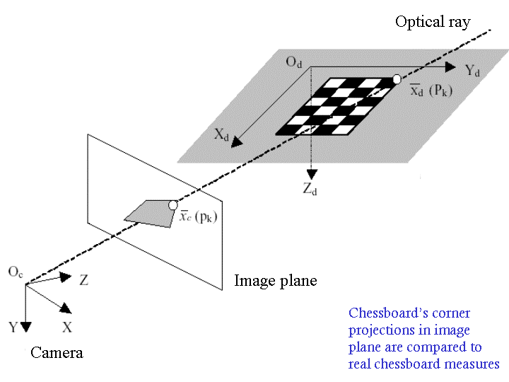

Fig. 16

To compute calibration we use the Intel computer vision toolbox for Matlab. This software, by connecting the parameters extracted from the two calibrations of the two virtual cameras, provides algorithms to extract grid corners, to correct image distortions, to find external and internal parameters and to build the stereo calibration.
By combining calibration parameters of the two virtual cameras it is possible to obtain a stereo representation of the chessboard and to reconstruct the virtual positions of the two cameras in the working 3D space (Fig. 17).
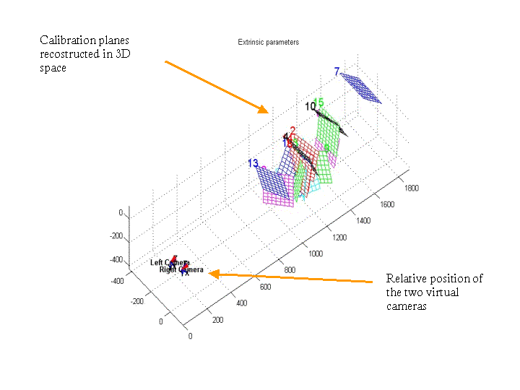

Fig. 17

Another important problem to solve is the correction of image distortion introduced by the lens. Our software is able to correct the distortion by using an Intel computer vision toolbox algorithm that we adapted for Visual Basic language. The final 3D reconstruction of point of interest (e.g. in our case, fingertips and wrist) is achieved through a rectification algorithm which allows to correct the relative rotations of the two virtual cameras and through another algorithm that uses the extrinsic calibration parameters and the points of the two bidimensional images.

- TMS studies in Humans

In addition to what originally planned, and still in the framework of the scientific problem of action recognition on which the MIRROR project is based upon, we decided to investigate some aspects in humans with electrophysiological techniques.
The hypothesis at the basis of the current project is that the mirror system is involved in the recognition of actions performed by others. Electrophysiological data (Fadiga et al. 1995) indicate that the motor system of the observer “resonates” according to the observed action. This resonance allows the observer to have access to the motor representation of the observed action, which is common to both the agent and the observer, giving to the observer an immediate knowledge of it.
A very recent neurophysiological experiment (Kohler et al. 2002) investigated whether there are neurons in area F5 that discharge when the monkey makes a specific hand action and also when it hears the corresponding action-related sounds, starting from the observation that a large number of object-related actions (e.g. breaking a peanut) can be recognized by a particular sound. The authors found that 13% of the investigated neurons discharge both when the monkey performed a hand action and when it heard the action-related sound. Moreover, most of these neurons discharge also when the monkey observed the same action demonstrating that these ‘audio-visual mirror neurons’ represent actions independently of whether them are performed, heard or seen.
These results have been very recently extended to humans by a TMS experiment (Fadiga et al., 2002) during speech listening. In agreement with the idea originally proposed by Liberman (Liberman et al., 1967; Liberman & Mattingly, 1985; Liberman & Wahlen, 2000), the authors started from the perspective that sounds conveying verbal communication could be a vehicle of motor representations (articulatory gestures) shared by both the speaker and the listener, on which speech perception could be based upon. In other terms, the listener understands the speaker when his/her articulatory gestures representations are activated by verbal sounds (motor theory of speech perception). To test this hypothesis, normal subjects were requested to attend to an acoustically presented randomized sequence of disyllabic words, disyllabic pseudo-words and bitonal sounds of equivalent intensity and duration. Words and pseudo-words were selected according to a consonant-vowel-consonant-consonant-vowel (cvccv) scheme. The embedded consonants in the middle of words and of pseudo-words were either a double ‘f’ (labiodental fricative consonant that, when pronounced, requires slight tongue tip mobilization) or a double ‘r’ (lingua-palatal fricative consonant that, when pronounced, requires strong tongue tip mobilization). Bitonal sounds, lasting about the same time as verbal stimuli and replicating their intonation pattern, were used as a control. The excitability of motor cortex in correspondence of tongue movements representation was assessed by using single pulse transcranial magnetic stimulation (TMS) and by recording motor evoked potentials (MEPs) from the anterior tongue muscles. The TMS stimuli were applied synchronously with the double consonant of presented verbal stimuli (words and pseudo-words) and in the middle of the bitonal sounds. Results (see Figure 18) showed that during speech listening there is an increase of motor evoked potentials recorded from the listeners’ tongue muscles when the listened word strongly involves tongue movements, indicating that when an individual listens to verbal stimuli his/her speech related motor centers are specifically activated. Moreover, words-related facilitation was significantly larger than pseudo-words related one.
Fig. 18

Starting from these results and in agreement with Liberman’s theory, it is obvious that a possible involvement of motor resonant mechanisms in speech perception can be postulated. Being this true, a temporary block of speech-related premotor centers should determine an impairment in speech perception.
With this aim we applied repetitive TMS (rTMS, that functionally blocks for hundreds milliseconds the stimulated area) on speech-related premotor centers during a phoneme discrimination task, in order to see if such an inhibition is able to induce a specific “deafness“ related to the phonologic characteristics of the presented stimuli.

Experimental setup
Subjects were seated on an armchair in a totally relaxed position. The backrest was inclined and the participant’s head lay on a headrest in order to maintain a comfortable and stable head position. Subjects were instructed to listen carefully to a sequence of acoustically presented pseudowords and to categorize the stimuli according to their phonological characteristics by pressing one among four different switches.
Acoustic stimuli were delivered through earphones connected to a personal computer that was used to present them in a randomized sequence. Stimuli consisted of 80 pseudowords subdivided into four different categories. Different categories referred to a different sequence of phonemes in the middle of the stimulus: “dada”, “data”, “tada”, “tata”.

/dada/  pipedadali  mafelodadafu  maludadafe  lupadadame  melumidadapo  lilamudadalo  lupidadapi  mifidadama  limelidadafa  felapudadapo  melamudadapa  fepodadala  pilimodadafa  fapedadafa  milidadame  pumopadadami  mufedadalu  pipufudadafa  fumodadala  pupiladadafe | /data/  pelemodatalu  pifidatafi  mufilidatami  fifudatali  mupodatali  pupudatame  mamofadatamu  pipudatala  lifupidatapa  lapaledatafe  popofudatali  fofelodatape  lifamedatami  momapedatafe  lefodatape  pifudatalu  fapumudatape  liloladatafo  pelupodatale  pelidatafi | /tada/  mamipotadame  lofutadapi  mifemutadame  lemitadafi  pupotadapa  fufoputadape  mofetadali  mapitadalu  mopotadafi  mepopetadamo  mapotadalo  famoletadala  pomafutadama  fofilitadalo  pumolitadala  fafetadape  famafitadalo  fopiputadame  lolifutadapu  femitadale | /tata/  pimatatape  lofimetatapu  pefotatamo  fumetatape  mimotatame  fapofetatafe  limitatamu  mimufitatalu  fepetatamo  fopolatatalo  fefitatama  pifutatali  pufefetatala  palitatamo  lamofotatamu  lopotatapi  fopumatatafe  melotatami  melutatama  mulilatatale

Subjects had to press the switch corresponding to the stimulus category as soon as possible (Fig. 19). The relative position of the different switch was balanced between subjects.
dada
data
tada
tata
Fig. 19

Participants’ left hemisphere was magnetically stimulated in three different regions by using rTMS. Magnetic stimuli were delivered through an eight-shaped coil placed on the skull with the handle positioned in a medio-lateral orientation. The experiment was subdivided into a mapping session and three experimental sessions. In the mapping session, the stimulation was made by applying magnetic stimuli on predetermined positions on a grid with a resolution of one-centimeter, drawn on a bathing cap wore by the participants. The coordinate origin was located at the Cz reference point determined according to the international 10-20 EEG system. The cortical representation of the anterior tongue muscles was mapped by moving the center of the coil by one centimeter-steps according to the grid. The motor evoked potentials from tongue muscles were recorded by surface electrodes inserted in a silicon sheet placed in contact with participants’ tongue.
In the experimental sessions, participants were asked to perform the task during a) rTMS of the focus of the tongue primary motor representation (B in Fig. 20), b) the rTMS of a region 2 centimeters more anterior (A in Fig. 20: premotor cortex), c) ) the rTMS of a region 2 centimeters more posterior (C in Fig. 20: somatosensory cortex) (Fig. 20)

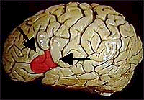
Fig. 20
A
B
C

Repetitive transcranial magnetic stimulation was delivered at a frequency of 20 Hz in correspondence of the 2nd critical formant, in correspondence of the 1st and the 2nd critical formants and also by means of a train lasting the entire critical syllable.
The hypothesis was that rTMS delivered in correspondence of the speech-related premotor region (A), by determining the temporary inhibition of the resonance system, should induce slower reaction times and a significant higher amount of errors in the discrimination task, with respect to the sessions in which regions B (?) and C were stimulated. Results, however, showed no difference between the performances obtained during the three different sessions of stimulation.
A possible interpretation of the absence of any effect of interference on phonologic perception could be that the discrimination task we used doesn’t, indeed, involve a phonologic perception. The task could be considered a mere discrimination task of the serial order of two different (not necessarily phonological) elements: “TA” and “DA”. It is possible that the way in which the subjects solve the task is the same he/she would use also in the case of two different tones and, possibly, involving structures different from the Broca’s area. Another possible interpretation is that the used stimuli (pseudo-words) are treated by the brain as non-speech stimuli, because they are semantically meaningless. We are currently psychophysically testing the different hypotheses in order to find out the experimental paradigm most adapt to be tested with rTMS.

REFERENCES

Fadiga L et al, 1995, J Neurophysiol, 73, 2608-2611
Fadiga L et al, Eur J Neurosci, 2002, 15, 399-402
Kohler E et al, Science, 2002, 297(5582), 846-8
Liu DM, Troczynski T, Tseng WJ, Biomaterials, 2001, 22(13), 1721-30
Liberman AM et al, 1967, Psychol Rev, 74, 431-461.
Liberman, AM and Mattingly IG, 1985, Cognition, 21, 1-36.
Liberman, AM and Wahlen DH, 2000, Trends in Cog Neurosci, 4, 187-196.
Szabo J and Cowan WM, J Comp Neurol, 1984, 222(2):265-300)
Umilta MA et al., Neuron, 2001, 31(1):155-65

