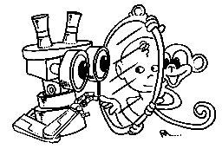 | MIRROR  IST–2000-28159  Mirror Neurons based Object Recognition

Deliverable Item 4.1

Protocol for Monkey Experiments

Delivery Date: April 30, 2002
Classification: Internal
Responsible Person: Prof. Luciano Fadiga – University of Ferrara
Partners Contributed:

Short Description: This deliverable item describes the experimental procedure and the experimental protocols that will be adopted during the in-vivo recordings in behaving monkeys. In particular the deliverable describes: 1) a new method that is being developed to precisely design the 3D shape of the chamber to be fixed to the skull. This method is based on precise 3D measures of the skull reconstructed from CAT scan and the computer aided design of a chamber perfectly adhering to the surface of the skull over the recoding site. 2) The surgical procedure that will be followed to implant the chamber; 3) The details of the single unit recording procedure during the experimental sessions. Considering that the experiments will be performed with behaving monkeys the comfort of the animal as well as the accuracy of microelectrode stereotaxic positioning have been carefully optimized. 4) Finally the outline of the experimental protocol is described. The goal of the experiment is to test the properties of single mirror neurons. This requires first characterizing isolated neurons according to their preferred modality (sensory or motor) and specific “mirror” properties. Successive to the initial characterization the neuron will be recorded during meaningful (for the neuron) grasping actions. This response elicited by the same grasping action will be recorded in different conditions of “visual feedback” and for different classes of neurons. The activity will be analyzed by comparing the frequency of discharge in the different situations. Video recording of the grasping movements will be performed simultaneously to compute hand grip and trajectory using a method under development that renders unnecessary the application of passive or active infrared markers on fingertips.
 | Project funded by the European Community under the “Information Society Technologies” Programme (1998-2002)

Content list

1. Introduction 2
2. Modeling the chamber for neuron recordings 2
3. Surgical procedure 4
4. Neuron recordings 4
5. Experimental paradigm 5

Introduction
Which is the mechanism at the basis of the philogenetic/ontogenetic development of the observation/execution matching system formed by mirror neurons? One possibility is that, during the ontogenetic process of motor learning, different visual information coming from the observation of one’s own hand performing repetitively the same action, are associated by the brain as “common signal” having in common the same motor goal. Thus, the sensorimotor coupling at the basis of the “mirror” mechanism would be initially generated by the observation of one’s own acting effector (e.g. the hand seen from different perspectives and, in particular in the first development phase, during several attempts to reach the target). This visuomotor transformation process, being at first a control system, could become more and more able to generalize the visuomotor association “visual hand-motor hand”. It could become therefore capable to extract motor invariants also during observation of actions made by others. The monkey experiment we are currently setting up is aiming to investigate the role of visual feedback relative to hand self-observation during grasping execution. The recordings will start at month 9 (with a four weeks delay with respect to the expected starting date) due to the time we devoted to some technical improvements. The experimental protocol have been developed specifically in our laboratory in the frame of the MIRROR project:

Modeling the chamber for neuron recordings
The procedure is composed of four steps.
- 3D reconstruction of monkey skull. By means of computerized tomography (CT) scan a series of horizontal slices (thickness, 1 mm) will be acquired (see Fig. 1)
- 3D reconstruction of the skull. By using the ETDIPS software, after converting the data into the Analyze format, the 3D external surface of the skull is reconstructed (Fig. 2) and the system of coordinates adjusted according to the standard stereotaxic system (orbitomeatal plane).
- With a specifically designed software (created in our laboratory) we determine the position of the target cortex (frontal area F5) by using as references both the sulcal pattern impressed on the internal surface of the skull (Fig. 3) and the stereotaxic atlas by Szabo and Cowan (J. Comp. Neurol. 1984 Jan 10;222(2):265-300).
- On the basis of the real curvature of the bone over the target cortex, we model the chamber starting from a virtual 3D shape created with a commercial 3D designing software. The obtained 3D file (see Fig. 4) is then sent to a path generating program (Mill Wizard, Delcam, UK) that outputs the correct G-code for driving a 3D milling plotter.

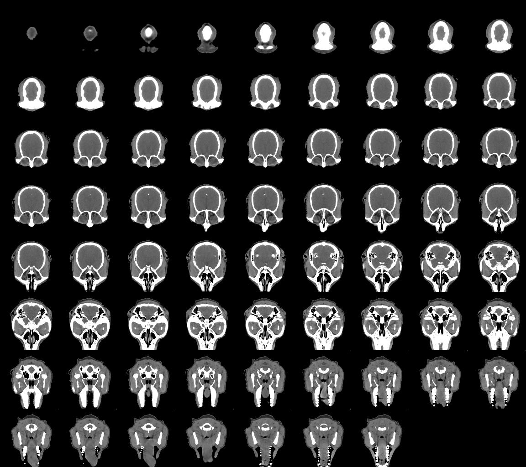 | Figure 1. Complete series of CT slices acquired from monkey MK1. The slice thickness is 1 mm. The slice pixel resolution is 0.24 mm. Note the high contrast between bone and soft tissues.

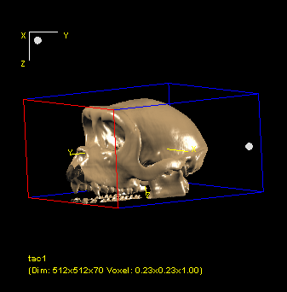 | 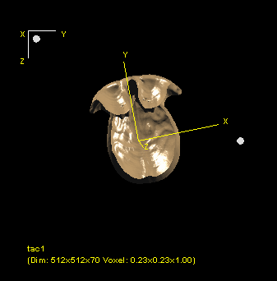
Figure 2. Anterolateral view of the 3D reconstructed skull of monkey MK1 | Figure 3. Internal surface of the reconstructed skull.

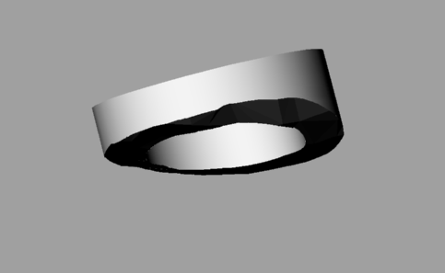
Figure 4. The modeled ‘virtual’ chamber for neuron recordings

We selected titanium for the chamber because of its excellent bio-compatibility. In this way we obtain a chamber with the inferior surface perfectly replicating the skull curvature. This technical improvement has important consequences because it reduces the possibility of liquid leakage from the chamber, it minimizes the use of acrylic cement thus reducing the probability of infections and increasing the duration of the implant. To stimulate a correct adhesion of the bone to the titanium we decided to coat the chamber and others implant components (screws, head fixation spheres, etc.) with hydroxyapatite (Ca10(PO4)6-(OH)2, HA). We follow a low temperature sol/gel coating procedure (Liu DM, Troczynski T, Tseng WJ. Water-based sol-gel synthesis of hydroxyapatite: process development. Biomaterials 2001 Jul;22(13):1721-30) to synthesize HA and to coat the metal. After brief drying at 80 °C the coated titanium is calcinated at 450 °C in order to obtain crystalline HA and to induce its adhesion to the substrate.

Surgical procedure
The most critical aspect during surgery is the respect of the thermal equilibrium of the exposed bone in order to maintain its vitality and allow its successive growth on the HA-titanium substrate. To this purpose, during the whole surgery and skull drilling in particular, care should be taken in order to prevent bone overheating. With this goal in mind we modified the illumination source of an operative microscope from the traditional bulb lamp to a fiber optic cold source system and we will irrorate continuously with saline the operative field during drilling. We designed a new system for head fixation during neuron recordings and new titanium screws that will improve implant duration. However, apart from these technical modifications the surgical procedure will develop according to standard protocols. An example of it can be found in Umilta MA, Kohler E, Gallese V, Fogassi L, Fadiga L et al. (Neuron. 2001 Jul 19;31(1):155-65)

Neuron recordings
During experimental days, the behaving monkey will seat on a restraining chair (see Figure 5). Arms and legs will be allowed to freely move.

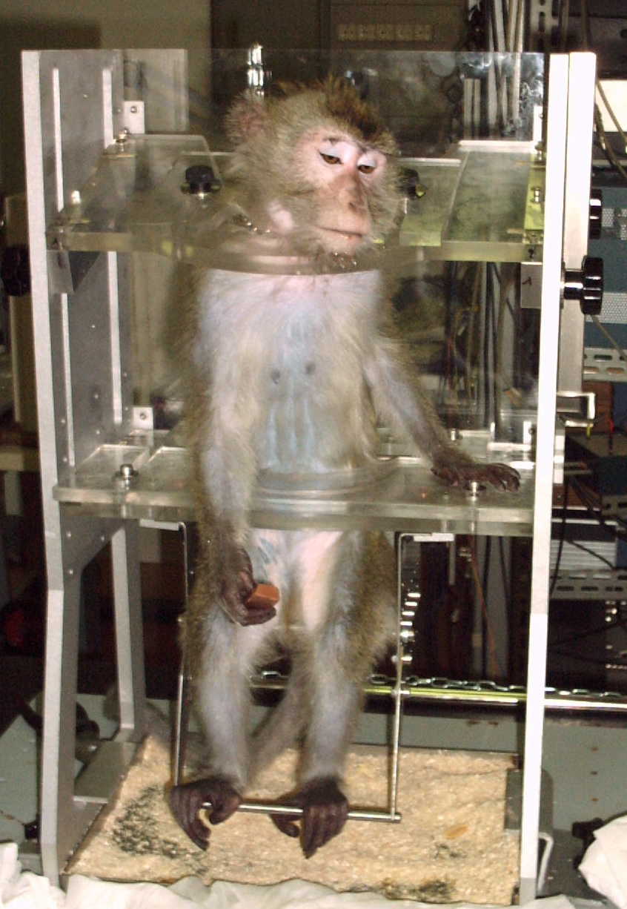 | Figure 5. The monkey chair. The head holding system is not shown. In the figure, monkey MK1 is grasping food during conditioning.
After head fixation by means of a specially designed frame in which four fixating rods are pulled onto the four titanium spheres chronically implanted on the skull, a specially designed prototype of micromanipulator (ASI Instruments) will be firstly used to calibrate the electrode tip position and then to move it to the desired location according to stereotaxic coordinate of the target region. The electrode will be inserted with an angle of 30° (with respect to the sagittal plane) in the premotor cortex with a hydraulic advancer (Trent Wells, CA, USA; step resolution, 10 um). Spikes will be amplified, filtered (World Precision Instruments, USA) and fed to an A/D converter for storage on a computer. The acquisition program has been specifically realized by our team. The electrical activity will be acoustically amplified by an Audio Monitor (Grass Instruments, USA) and will give to the experimenter a fundamental feedback during neuronal testing.

Experimental paradigm
After characterization of isolated neurons (motor, visuomotor, visual, mirror, grasp specificity, etc.) the activity of selected mirror neurons will be recorded during execution of hand grasping movements towards a box containing some food (raisins, pumpkin seeds, apple pieces, etc.). The transparent cover of the box will host one among various plastic objects (the most appropriate one will be selected by the experimenters according to grasping selectivity of the recorded neuron) that must be grasped in order to remove the cover and to reach the food. Grasping will be performed by the monkey in: a) full vision (both object and hand visible), b) without hand vision (only the object will be illuminated) and, c) with a manipulated visual feedback (object will be dimly illuminated and the position of fingertips will be shown to the monkey by means of LEDs glued on finger nails. Note that the presence of a dim light inside the object will allow grasping in the dark condition and light feebleness will be required in order not to illuminate the hand when it is reaching the object). During the experiment not only mirror neurons but also F5 motor neurons will be recorded and submitted to the same experimental paradigm. Analysis will compare the frequency of discharge in the three experimental conditions in both neuron categories. The study of F5 motor neurons is further important in order to exclude that the expected modification of mirror discharge are due to difference in motor execution induced by the experimental manipulations. During grasping hand/wrist kinematics will be recorded by means of a 3D video acquisition system (actually under development in our lab) that computes the hand grip and trajectory by reconstructing the 3D poses of finger and wrist in action filmed from different point of view. This system represents a remarkable improvement for the study of monkey hand movements, because it renders unnecessary the application of passive or active infrared markers on fingertips (as required by the commercially available systems) that negatively influences the collaborative behavior required to the animal during recordings. Note that also Uppsala group (UU) would benefit from such a technology for their kinematic recordings in children.

