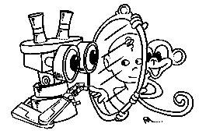 | MIRROR  IST–2000-28159  Mirror Neurons based Object Recognition

Deliverable Item 2.1 and 2.2

Robot Set-Up Specification and Design

And

Robot Set-up

Delivery Date: November 15, 2002
Classification: Public
Responsible Person: Prof. Giulio Sandini – University of Genova
Partners Contributed: IST - Lisbon
Short Description: These Deliverables describe the work we carried out with the robotics setups. This activity has been divided in two parts: the design and realization of a robot hand and the execution of some preliminary experiments of reaching/grasping. The initial plans were to design a whole arm-hand system, however, we decided to concentrate our effort on the design of a robot hand because, on one side, it represents the main “tool” for addressing grasping issues and, on the other, we estimated that our current robot arm is perhaps sufficient for the goals of the project.
 | Project funded by the European Community under the “Information Society Technologies” Programme (1998-2002)

Content list

1. Introduction 2
2. Robot Hand 2
2.1. Robot’s “posting” experiment 4
2.2. Learning to push 4
APPENDIX 6

Introduction
Considering that the main goal of MIRROR is to study the issue of manipulation our intention since the beginning has been to develop an arm-hand system with requirements defined by the scientific (biological) questions more than by “traditional” requirements like force, speed and accuracy. During the definition of the system it turned out that, within the funding budgeted for this part of the project, it was possible either to design a full arm-hand system with “reduced” performance or to design a more sophisticated hand to attach to our currently available arm (an “off-the-shelf Unimation PUMA-260). For the purpose of the project we decided to opt for the second solution and proceeded in that direction. In the meantime we also continued performing experiments with our robot system by using the already available arm and controlling its degrees of freedom at the wrist as simple initial components of grasping. Some of these experiments were defined together with the group at the University of Uppsala so that a similar experiment was planned and carried out with infants of different age (see DI-4.2 and DI-4.4 reporting the design and preliminary results).

Robot Hand
The main specifications of the robot hand are:
- Shape as much as possible similar to a human hand. This is particularly important for Mirror because we want to design a tool, which, not only moves like a human hand, but also looks like a human hand. We want to test how our system learns to discriminate between different grasps “simply” by looking at the hand during execution of the grasp. For this reason we opted for a 5-finger hand of about the same size of a human hand.
- Enough degrees of freedom to allow the generation of, at least, three different grasp types. To allow different grasp types to be performed without controlling unnecessary degrees of freedom, we opted for a kinematic configuration where 16 joints are controlled by “just” six motors and the redundancy is managed by elastic couplings (springs) between some of the joints. The six actuators are assigned so that two of them control the thumb, two the index finger and the last two are used to control the last three fingers.
- Rich sensory information; Because of the elastic couplings of some of the joints, position sensors (Hall effect sensors) have been included in all 16 degrees of freedom. This should allow measuring position and torque on all joints (by exploiting the combination of the encoders and the Hall effect sensors).
Figure 1 presents the CAD design of the robot hand (panel A, B, and C) in a few grasping configurations and a picture of the actual hand. Panel D shows the index finger of the robot hand compared to the size of a human hand.

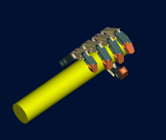  A | 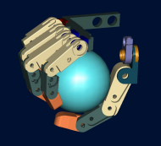  B | 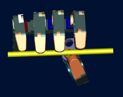  C
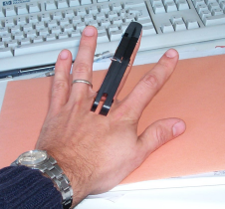  D | 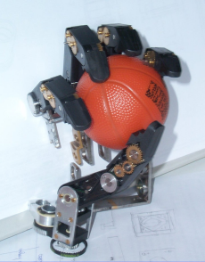  E | 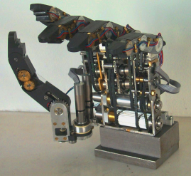  F
Figure 1: Robot hand. The hand was designed in collaboration with CM Ingegneria and TELEROBOT S.r.l.
A sample of one of the mechanical drawings is presented in the appendix along with the list of all drawings. The intellectual property of the hand belongs to DIST - University of Genova.
The robot hand will be connected to a PC through an axis control board (GALIL) and an A/D conversion board from National Instruments to acquire all proprioceptive data from the “hall effect” sensors of the hand.
The robot hand is attached to the arm through a sensor from JR3 measuring force and torque at the wrist. The overall configuration of the robot system is shown in the following .
The current status of the set-up is that we finished the functional tests of the single joints and started the cabling to test multiple joints movement.

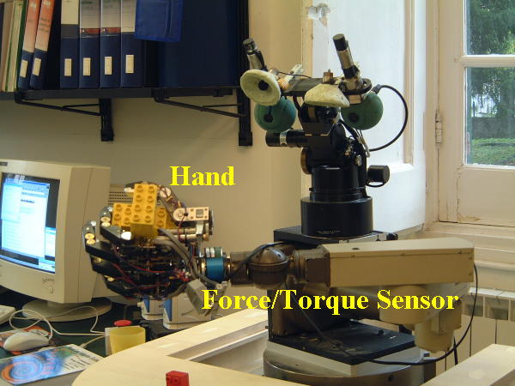
Figure 2: Picture of the robot with the hand and wrist

Robot’s “posting” experiment
During the first year the robot hand was not available. On the other hand we wanted to start addressing the “grasping issue” from the modeling point of view and for this reason we decided to perform two experiments. The first one, which we called the “posting” experiment, involves the control of the orientation of the hand. The robot has to learn the correspondence between the orientation of a visually identified “slit” and the correct orientation of the “hand”. The rationale being that the orientation of the hand is a “parameter” controlled by the “grasping” (pre-shaping) mechanism controlling the hand posture and not by the “transport” mechanism controlling visually guided reaching. It is worth noting that the same experiment has been planned with young infants and the corresponding results are reported as part of Workpackage 4. The experimental setup of the posting experiment is shown in Figure 3. In this particular experiment we integrated the control of the orientation with the transport phase of the reaching task modeling the incremental acquisition of motor skills found in human infants.

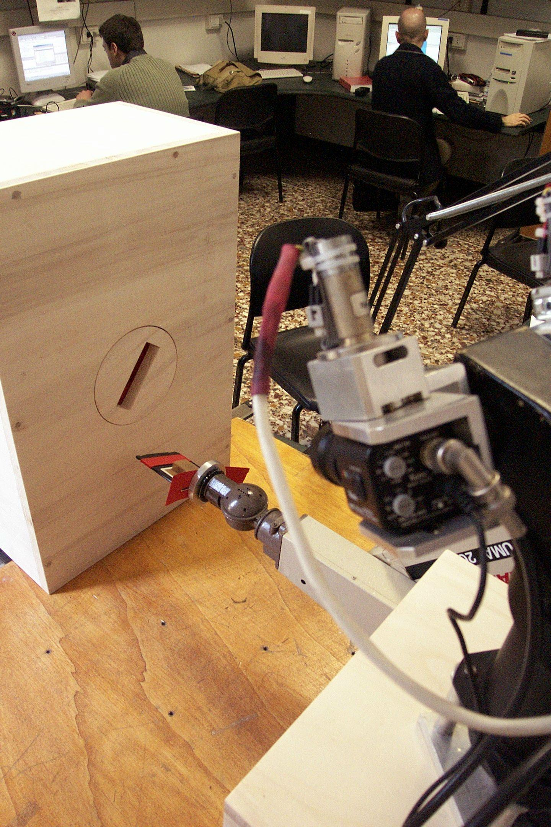  A | 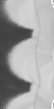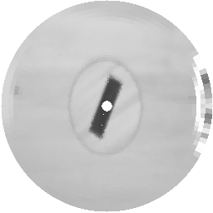  B
Figure 3: A: Setup of the "posting" experiment. B: Images acquired by the visual system of the robot to control the orientation of the paddle-hand.
In the experiment performed so far no force/torque information is used to correct the orientation error.

Learning to push
With the idea of starting to address the problem of the learning of the consequences of self-generated actions (and keeping in mind that we did not have a hand to control), we decided to study the action of pushing. In particular we investigated how a robot can learn which motor synergy is more appropriate to push an object in specific directions.
Learning to act involves not only learning the visual consequences of performing a motor action, but also the other way around, i.e. using the learned association to determine which motor action will bring about a desired visual condition. Along this line we have shown how our humanoid robot uses its arm to try some simple pushing actions on an object, while using vision and proprioception to learn the effects of its actions. We have shown how the robot learns a mapping between the initial position of its arm and the direction the object moves in when pushed, and then how this learned mapping is used to successfully position the arm to push/pull the target object in a desired direction. In Figure 4 an example of a learned action is shown. After the robot has identified the object and the target because of the different colors, it selects the proper learned action to push the object in the direction of the target.
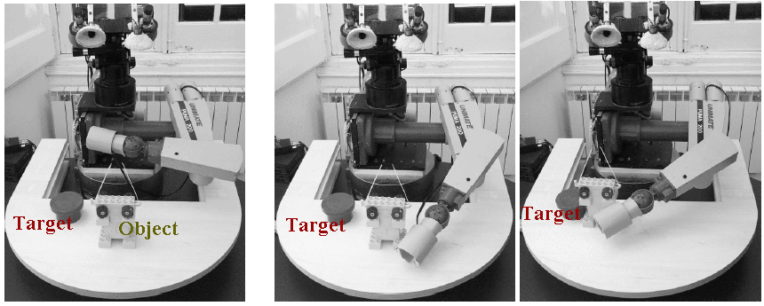
Figure 4.: Sample action after learning. The robot task is to push the "Object" towards the "Target". This is performed by a learned "swiping" motion.

APPENDIX
Listing of parts of the more than 500 components of the hand and a sample drawing
===============================================================================================
Assembly : T03308A002 Rev 0 - TLR-H&1
-----------------------------------------------------------------------------------------------
Codice Rev Qtà Descrizione Tipo Pro/E
------------------------- --- --- --------------------------------------------- --------------
T03308P204 0 1 TELAIO Sub-Assem
T03308P076 0 1 SUPPORTO 5° DITO Part
V3-6--_-_U5933_C 10 VITE TSPEI UNI 5933 M3X8 Part
T03308P077 0 2 SUPPORTO 2°, 4° DITO Part
T03308P091 0 1 SUPPORTO 3° DITO Part
618-7 4 CUSC.RAD.SFERE 1COR. 7X14X4 :SKF 618/7 Part
T03308G001 0 1 1° MOV. 3°, 4° E 5° DITO Sub-Assem
T03308P080 0 2 RONDELLA Part
V4-8--_-_U5933_C 2 VITE TSPEI UNI 5933 M4X8 Part
T03308P078 0 2 MORSETTO ELASTICO Part
R2--_-_U6592 4 ROSETTA UNI 6592 2.2X5 Part
V2-8--_-_U6107_C 6 VITE TCI UNI 6107 M 2X8 Part
T03308G002 0 1 2° MOV. 3°, 4° E 5° DITO Sub-Assem
1224S_12-4-256_30B20 0 2 FAULHABER TIPO 1224S - RID. TIPO 12/4-256 ENC Part
V2-4--_-_U6109_C 4 VITE TSPI UNI 6109 M 2X4 Part
T03308P079 0 2 PULEGGIA #13 Part
G3-3--_-_U5923_G 2 VITE STEI ESTR.PIANA UNI5923 M3X3 Part
