IIT Genoa
Presents
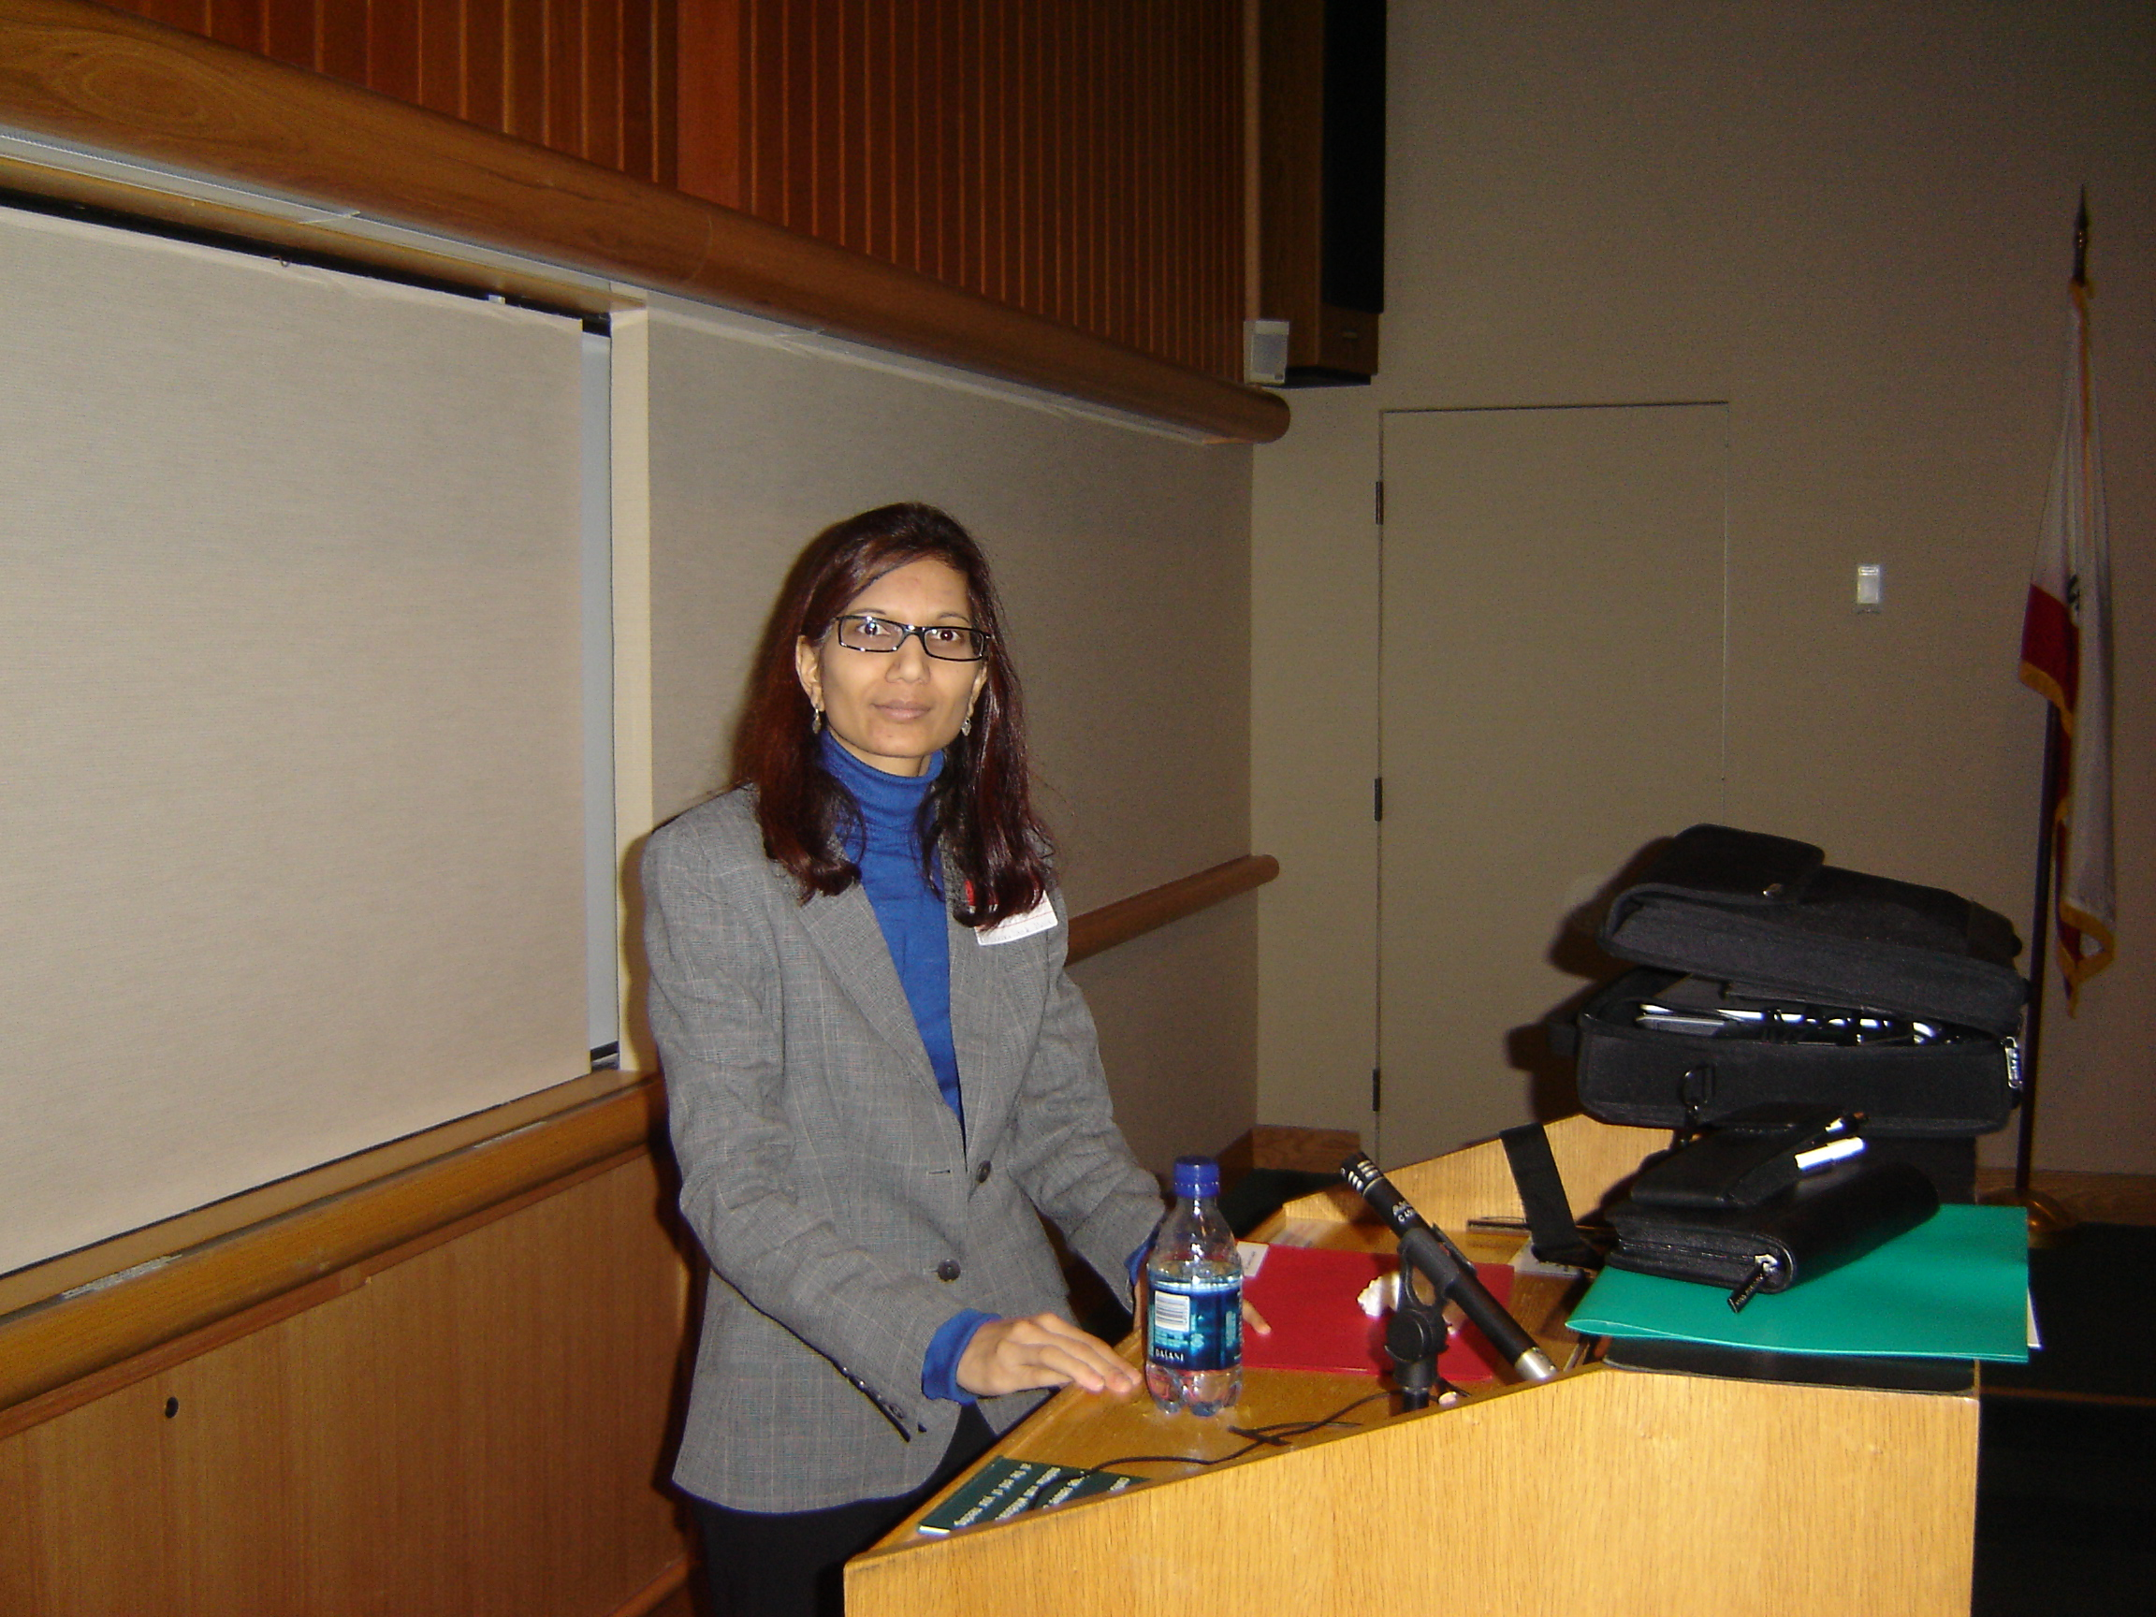
Dr. Sanju Gupta
ECE Department and MURR
University of Missouri (USA)

Thursday, July 02nd 2009 @ 11.30 a.m.
Venue: Meeting Room 4th Floor
Presently A Visiting Scholar @ PolitTO
Dr. Gupta is presently working at MU and MURR, previously worked at NCSU-Raleigh with Bob Nemanich and Cambridge University-UK with John Robertson, obtained doctorate in Materials and Chemical Physics at UPR-San Juan, ME in Lasers and Photonics from Indian Institute of Technology, Kanpur with Rank 1, MS in Physics from Indian Institute of Technology, Delhi and BS Phys. (Hons.) from Delhi University with distinction. Awards: Among others, she is the Recipient of JSPS Fellowship (NIRIM, Japan), Recipient of NSF Graduate Fellowship (US), Recipient of Commonwealth Fellowship (UK), Recipient of JN Tata Fellowship, Visiting scholar in Turin (IT), Recipient of Best Poster Award at SSP conference in Columbia, MO. Chair and Organizer of IMAPS Workshop on Advanced Substrates, Chair & Co-chair of MRS Symposium on Irradiation Studies and Nanocomposites and ICCE Conference among several synergistic activities.

[1] Gupta et al. APL 86 (2005) [VJNST, 2005]; [2] Gupta, et al. JAP 95 (2005) [VJNST, 2004]; [3] Wang, Gupta, Nemanich, APL 85 (2004) [VJNST, 2004]; [4] Gupta et al. JVSTB (2008), [5] Bianco, Gupta et al. IEEE Nano (2009), [6] Ray, Gupta, Tagliaferro, et al. J. Nanosci. Nanotech. (2009).
Research Interests: Carbon nanotubes, Nanomaterials Processing (irradiation and thermal), Electronics/Electrical/Vibrational spectroscopy/Nanomagnetics, Nanoscale Self-Assembly by hydrogen bubbles, Electrochemical and Nano Devices, Conducting Polymers, Artificial Muscles, Ferroelectrics, Novel Forms of Carbon, Diamond and Nanodiamond, Plasma-enhanced and Thermal CVD, Chemical Solution Deposition, Protein functionalized nanodiamond and nano-bio interface and SPM.

Host and Contact Email: davide.ricci@iit.it
Multifunctional Nanostructured Carbons
The talk will be comprised of two parts presenting the recent activities related to plasma-enhanced CVD grown vertically-aligned carbon nanotubes (VACNT) and nanodiamond wherein materials science played a vital role in discovering these novel forms carbons with tailored structural and physical properties for desired technologies such as vacuum microelectronics.
Electron field emitting materials known as cold cathodes (i.e. emitting electrons at room temperature) are of vital importance facilitating FEDs, RF/MW amplifiers for communication and radar, as bright electron beam for microscopes, electric propulsion for microsatellites and portable X-ray sources for medical and security diagnostics. In the quest for potential cold cathodes, CNTs in the family of nanostructured carbons proved to be the most viable candidate material as planar cold cathodes yet having nanoscale heterogeneities. Starting with a brief introduction on the syntheses of VACNT films using PECVD technique, where experiments showed by continuous reduction in catalyst thickness, hollow single-walled tubes in contrast to bamboo-like multiwalled tubes can be produced, the traditional field emission (I-V) properties and temperature dependent field electron emission microscopy (T-FEEM) enabling real-time imaging of electron emission with high spatial resolution providing evident information on emission site density, temporal variation or flicker of the emission intensity and insight into the role of adsorbates from nanotube films will be presented. Physics-based models (negative or low electron affinity, geometric enhancement, surface dipole, local work function etc.) are used to support the experimental observations. Temperature dependent field emission findings will also be related to vacuum thermionic energy/power converters. n-type doping in diamond is a central topic for the development of diamond-based electronics. Thus sulfur doping in nanodiamond will be briefly mentioned in the context of providing equivalent electron emission properties to those of carbon nanotubes [1-4]. Lastly, recent activity in nanomagnetism of Fe-based catalysts and thermal treatment of carbon nanotubes giving rise to modified physical properties will be called to attention [5, 6].

